Old UI Design
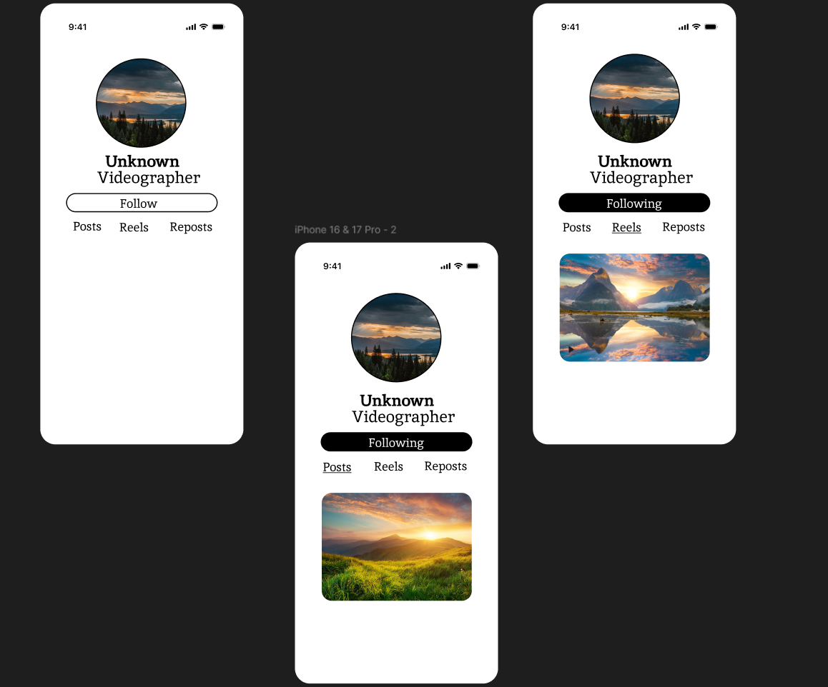

Features & Drawbacks Identified:
- Flat & Empty Layout:
o No cover image or visual elements — profile feels plain.
o Too much empty space reduces engagement.
- Missing Profile Details:
o No bio or stats shown.
o Hard to understand account activity.
- Weak Navigation:
o Tabs are not clearly highlighted.
o Active section is hard to notice.
- Low Content Visibility:
o Only one post preview shown.
o No grid — browsing feels limited.
- Weak Visual Hierarchy:
o Important info does not stand out.
o Typography lacks emphasis.
- Limited Interaction Options:
o Few action buttons (no message/share).
o No engagement metrics displayed.

New UI Design
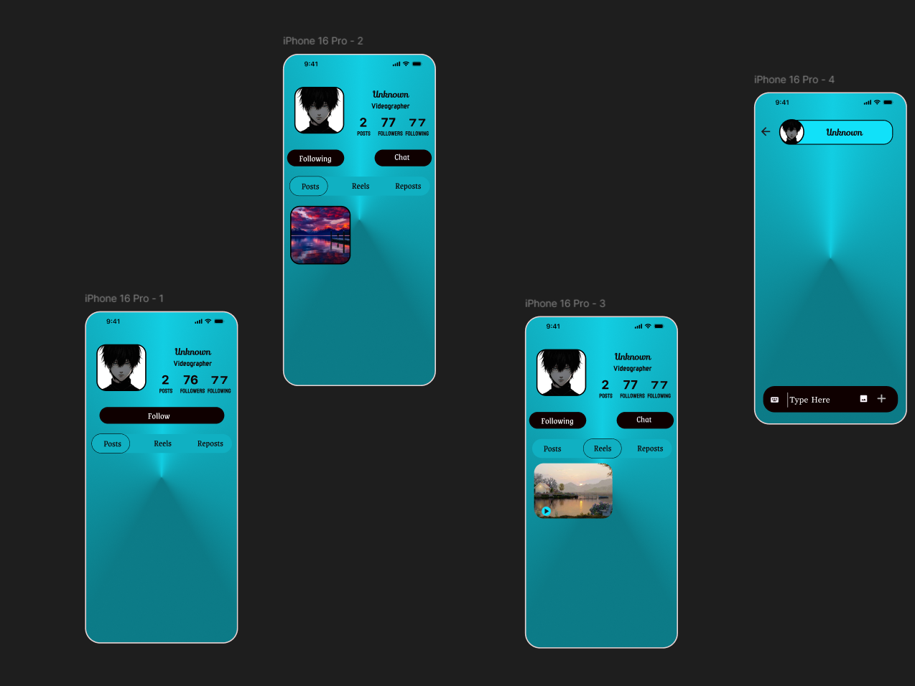

Features & Enhancements:
- Gradient & Modern Background:
o A smooth gradient background gives a modern and visually appealing look.
o Adds depth and makes the interface feel lively.
- Enhanced Profile Header:
o Profile section is compact with clear alignment.
o Information is organized neatly for quick viewing.
- Clear Profile Stats:
o Posts, Followers, and Following are displayed prominently.
o Improves understanding of user activity at a glance.
- Strong Call-to-Action Buttons:
o Follow/Following and Chat buttons are clearly visible.
o Rounded styling improves usability and visual appeal.
- Improved Navigation Tabs:
o Posts, Reels, and Reposts are styled as selectable chips.
o Active tab is clearly highlighted for better navigation.
- Better Visual Hierarchy:
o Username is bold and stands out.
o Role (Videographer) is shown as secondary information.
- Engaging Content Preview:
o Media previews with rounded corners look clean and modern.
o Content is easy to browse.
- Interactive Elements:
o Chat screen includes input bar and action icons.
o Enhances communication functionality.

